Session :- 1

1.Download and install Power BI Desktop on your computer, then open the application and take a screenshot of the blank report interface.

Answer: 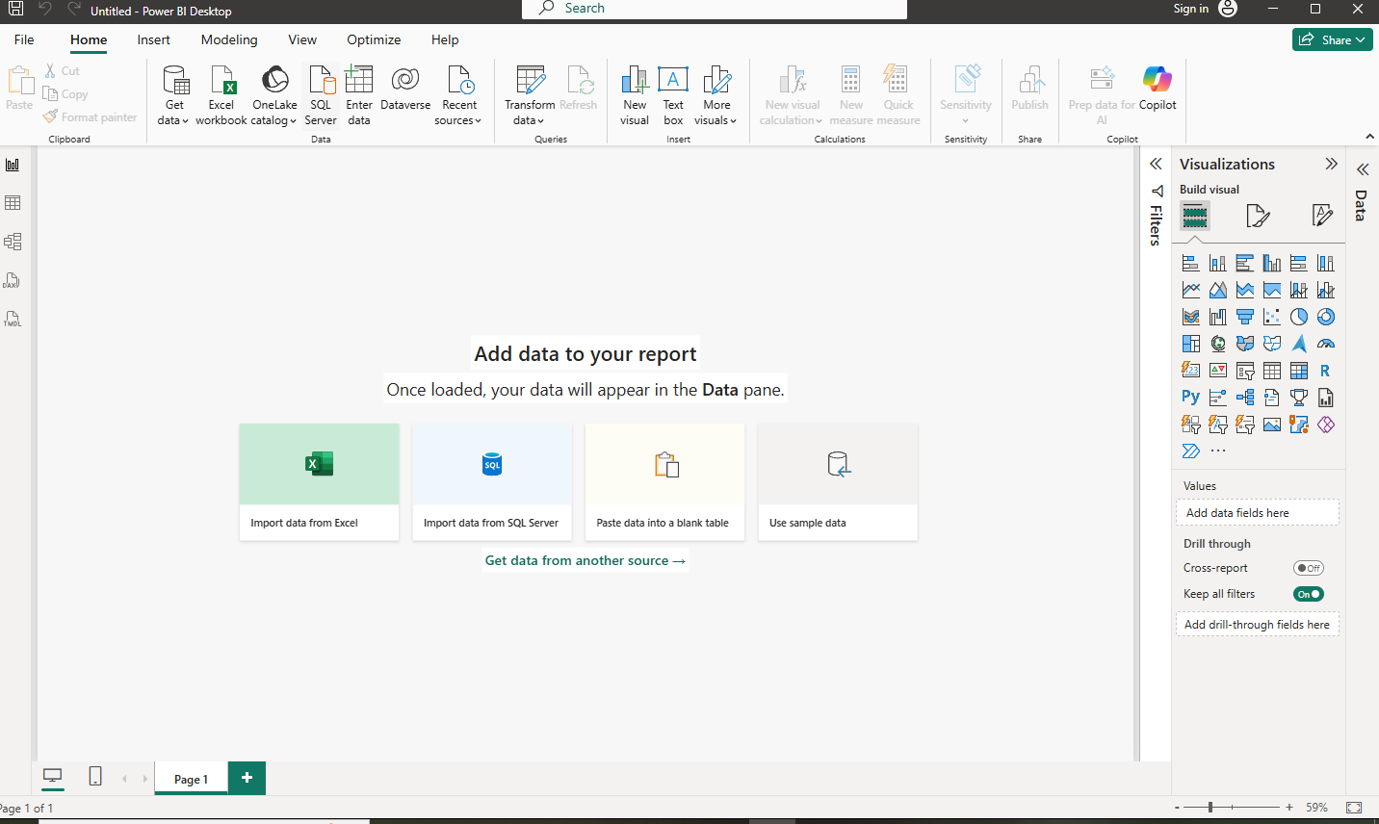

2.Explore the Power BI Desktop interface and identify the following components: Report View, Data View, Model View, Fields Pane, Visualizations Pane, and Filters Pane. Write a short description (1-2 lines) for each component.
Answer: Power BI Desktop Interface Components
1.Report View: – Used to create and design reports by adding charts, tables, graphs, and other visualizations to report pages.
2.Data View: – Displays the actual data in tables. It allows you to inspect, filter, and work with the data loaded into Power BI.
3.Model View: – Shows the relationships between different tables in the data model. It is used to create and manage relationships between tables.
4.Fields Pane: – Lists the tables, columns, and measures available in the data model. Users can drag these fields into visuals to build reports.
5.Visualizations Pane :– Contains different types of charts and visual formatting options. It is used to select, create, and customize report visuals.
6.Filters Pane: – Allows users to apply filters to data at the visual, page, or report level. It helps control which data is displayed in the report.

3.
Create a new blank report in Power BI Desktop and add a table visual using the Visualizations Pane. Rename the report page to 'My First Dashboard'.
Answer: 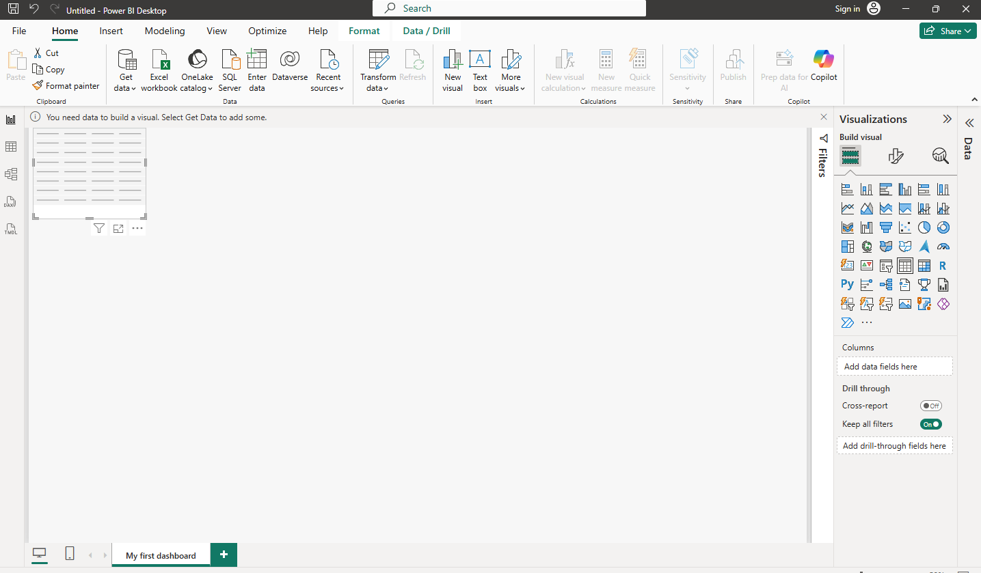

4.
List 3 key differences between Excel Dashboards and Power BI Dashboards, focusing on features or workflows you noticed while exploring Power BI Desktop.
Answer:3 Key Differences: Excel Dashboards vs Power BI Dashboards
Feature Excel Dashboard Power BI Dashboard
1. Data & Modeling Data is mainly managed through worksheets, formulas, PivotTables, and charts. Power BI has dedicated Data View and Model View for data transformation and table relationships.
2. Visualizations Uses Excel charts, PivotCharts, and slicers with relatively limited interactive options. Provides many interactive visuals, with a Visualizations Pane for creating and formatting charts.
3. Filtering & Interactivity Filtering is commonly done using filters, slicers, and PivotTables. The Filters Pane supports visual-, page-, and report-level filtering, making dashboards more interactive.

4.
List 3 key differences between Excel Dashboards and Power BI Dashboards, focusing on features or workflows you noticed while exploring Power BI Desktop.
Answer:
